How To Guide for CA1 - Statistical Techniques for DA

Once you have completed your survey on Google Forms. Log in and click on the Responses Tab.
https://docs.google.com/forms

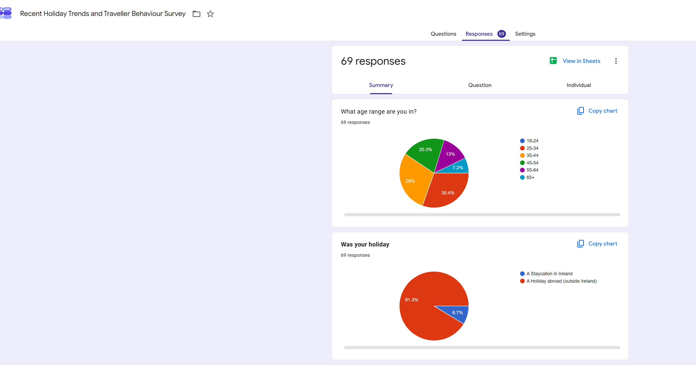

See above

You now want to download your results into a csv format. Click in the link -View in Sheets.

A Google Sheets file will appear. Click on:
File – Download – Comma Separated Values (CSV)
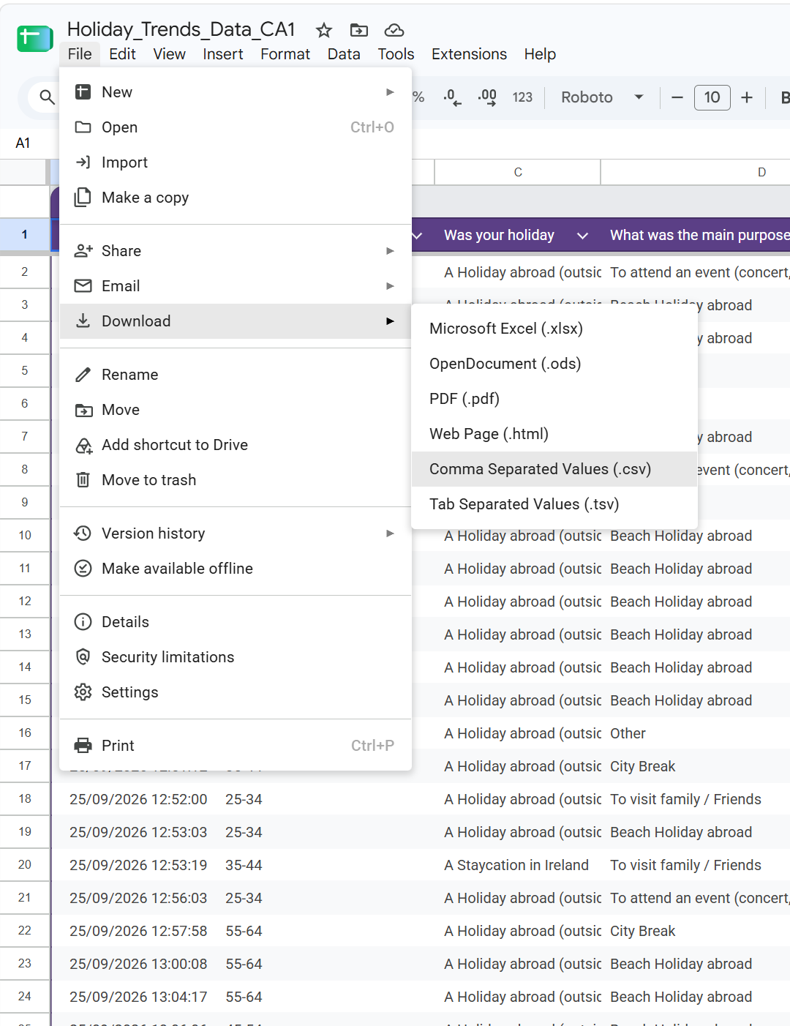

You will see the file in your downloads
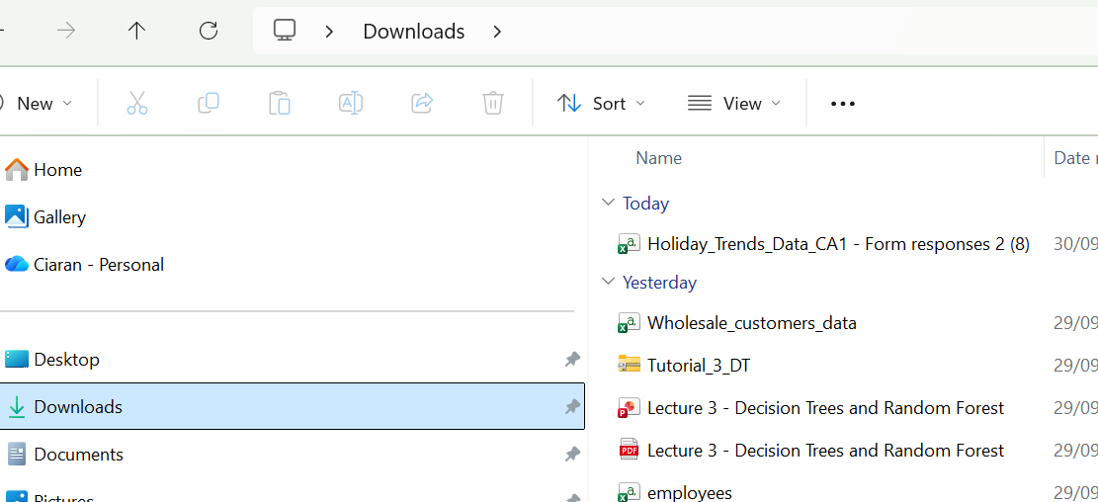

See above
Double click on this file to open then
File - Save As:
Rename to: Data_CA1 (As per Assignment directions)
Make sure its saving as a CSV
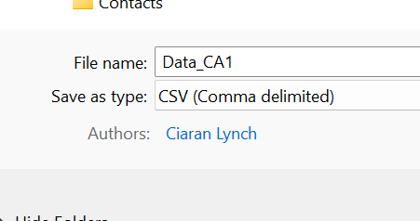

Now make sure that you are putting the file into the folder where Juypter Notebook reads from:
On My pc, Jupyter reads from
C:\Users\ciara (Thinks I am a woman)
I created a sub Folder called:
C:\Users\ciara\Statistical Techniques For Data Analysis and saved the file there
Jupyter Notebook
You can now open Jupyter Notebook, via anaconda.
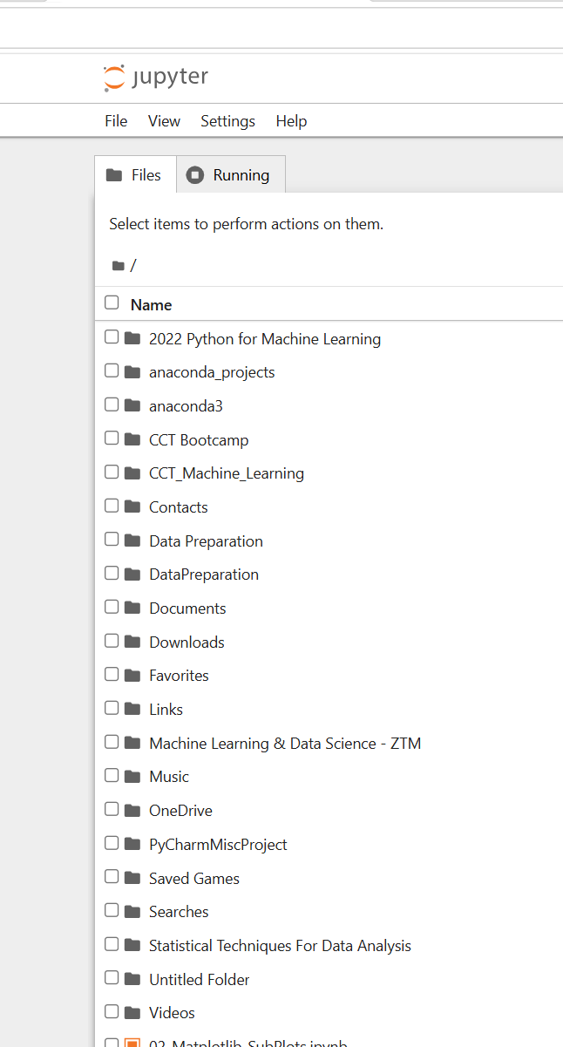
Click on your sub-Folder, if you have one and create a new Python file
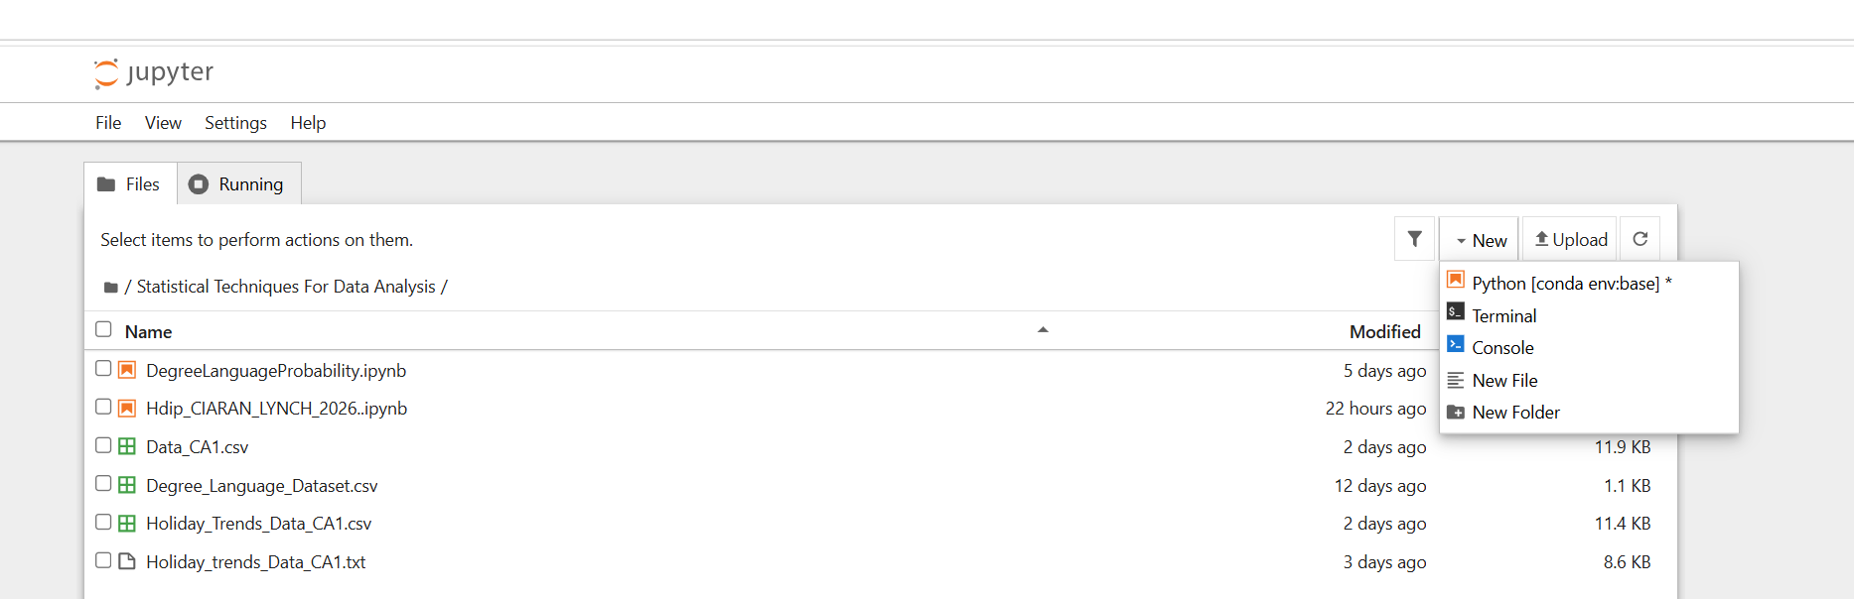

Again, as per CA1 directions, I have named the file:
Hdip_CIARAN_LYNCH_2026.ipynb

I gave my Python script a heading.
Type in the first line and use

#Recent Holiday Trends…
Change the file from code to Markdown
Remember
# = Heading 1 and ## = Heading 2. ### or #### tends to be more normal text

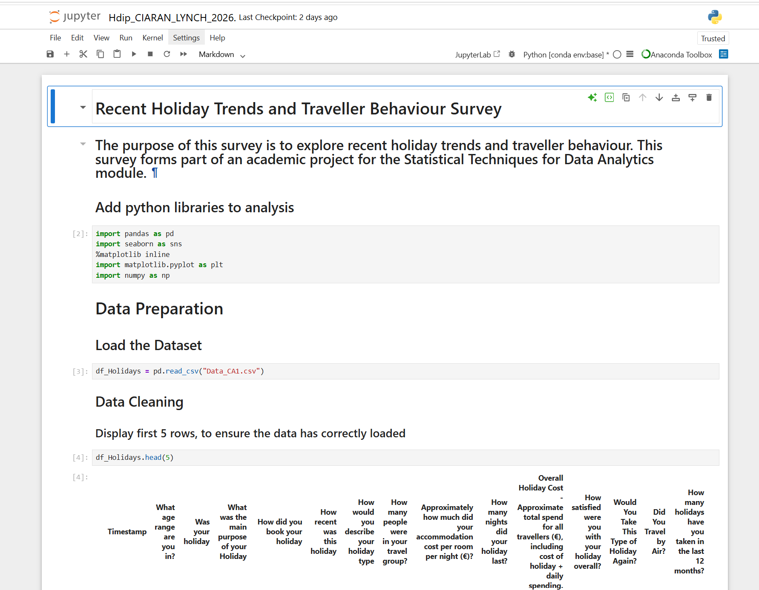

Remember:
Step 1 Add the libraries.
Step 2 Load the data
df_Holidays = pd.read_csv("Data_CA1.csv")
Step 3 Data Preparation
df_Holidays.head(5)
df_Holidays.shape
df_Holidays.info()
df_Holidays.isnull().sum()
Rename Columns:
df_Holidays = df_Holidays.rename(columns={
"Timestamp": "Timestamp",
"What age range are you in?": "Age_Range",
"Was your holiday": "Holiday_Location",
"What was the main purpose of your Holiday": "Holiday_Purpose",
"How did you book your holiday": "Booking_Method",
"How recent was this holiday": "Holiday_Recency",
"How would you describe your holiday type": "Holiday_Type",
"How many people were in your travel group?": "Group_Size",
"Approximately how much did your accommodation cost per room per night (€)?": "Accommodation_Cost",
"How many nights did your holiday last?": "Holiday_Length",
"Overall Holiday Cost - Approximate total spend for all travellers (€), including cost of holiday + daily spending.": "Total_Cost",
"How satisfied were you with your holiday overall?": "Satisfaction",
"Would You Take This Type of Holiday Again?": "Holiday_Again",
"Did You Travel by Air?": "Travel_By_Air",
"How many holidays have you taken in the last 12 months?": "Holidays_Last_12_Months"
}
)

Once you have finished the Data Preparation, you can move onto:
Descriptive Statistics
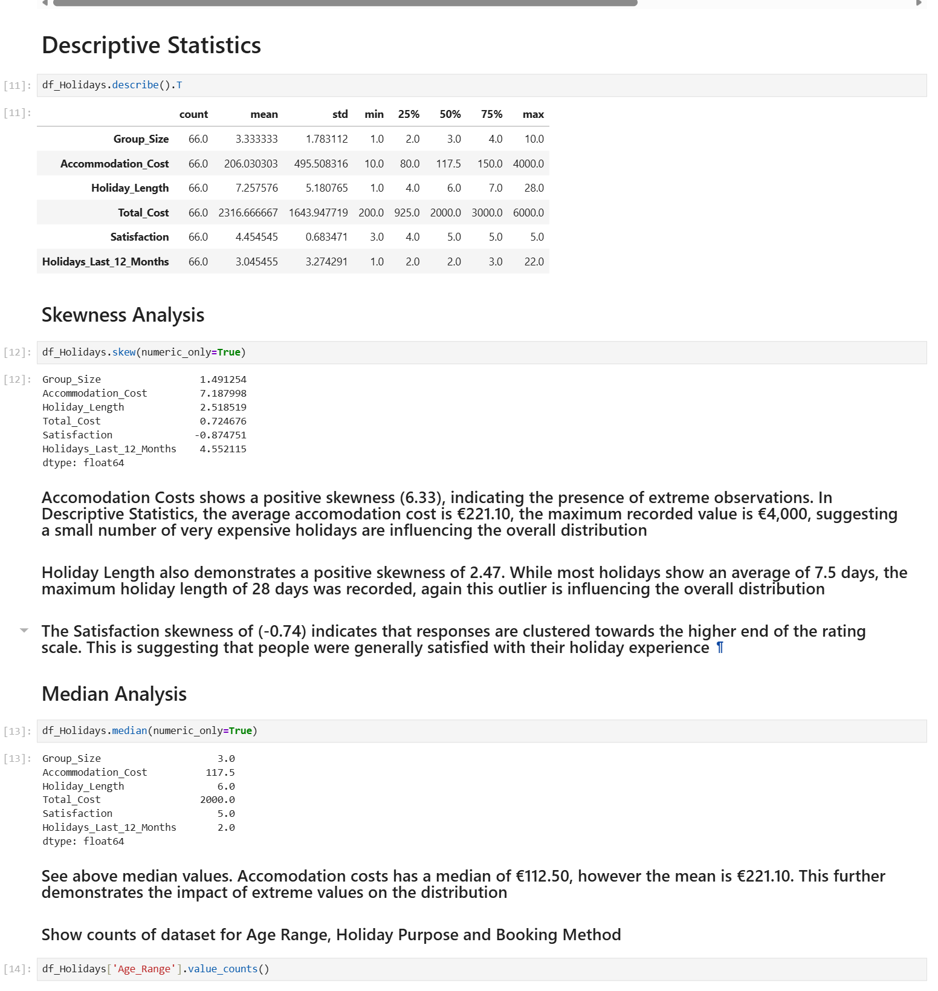

Writing your Report
On the CA1 Document, we are told to create a word report of approx. 1,000 words.
I again have save the word document as:
Hdip_CIARAN_LYNCH_2026.docx
The 3 main areas that we need to discuss are:
Introduction
Analysis & Insights
Conclusion and Outlier Analysis

Create those 3 lines above and make them a Heading1. Then create a table of Contents

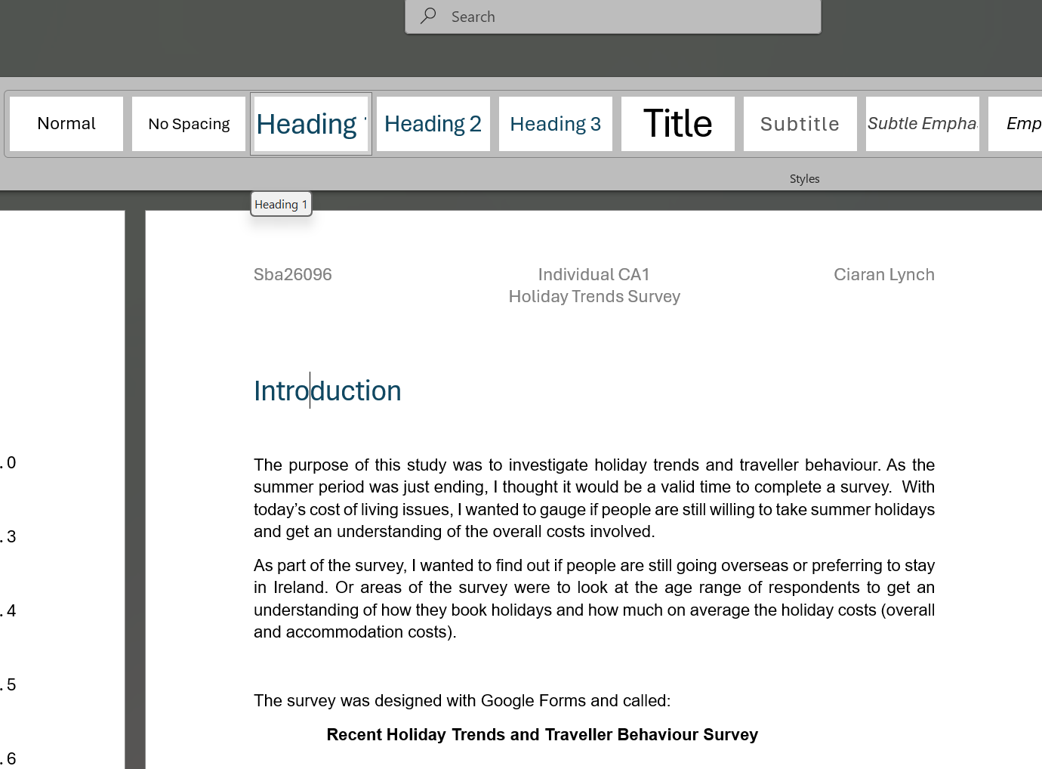

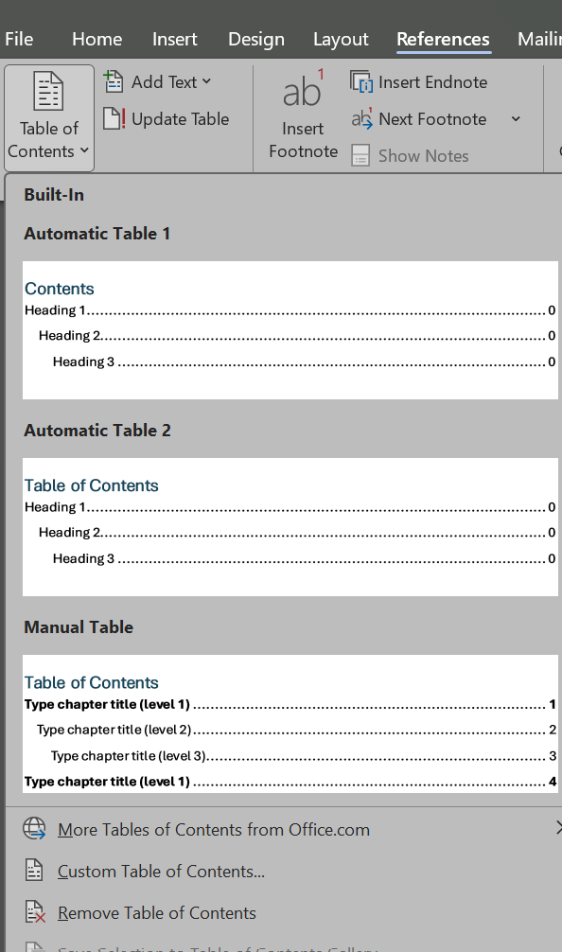

Downloading your Jupyter Notebook File
To download your Jupyter Notebook, simply select
File – Download
Again, this will go to your downloads folder and you can upload it to Moodle.
If you have GitHub set up:
Simply, go to you appropriate Github loation, for this module:
Select Add File – Upload Files
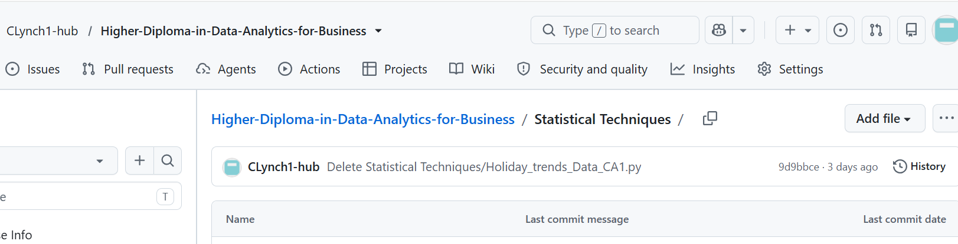

Drag the files from you downloads and the word report from the folder where it is saved and drop them into the add files box.
Once you see the files listed – click Commit Changes

